South Eastern Idaho Reservoirs

BVFF Outing April 2014
Date: April 17 – 20, 2014
Host: Bert Williams 208-631-8507
Campground: Devil Creek Reservoir
Cost: Campground Reservations Contact – Nancy Facer 208-251-7540
- $25 – Full Trailer Hookup (Water, Power)
- $10 – Trailer Parking without hookups
- $8 – Tent camping
Devil Creek Directions:
- 225 mi (3.5 Hours) – Drive to Pocatello Idaho
- Merge onto I-15 S/US-91 S toward Inkom/Salt Lake/McCannon.
- 30 to 40 mi (approximate) Between Arimo and Virgina
- Look for Devils Creek on the left, rust off of the Interstate

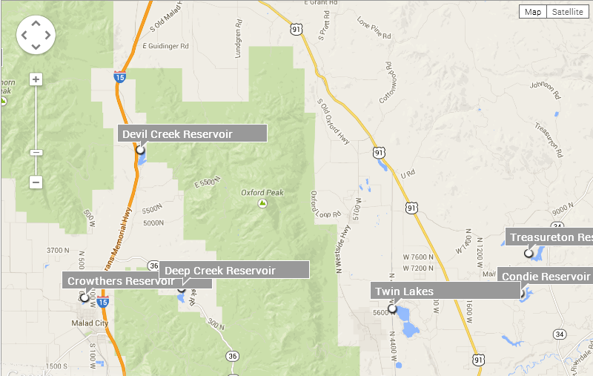
Bring your pontoon boats and/or float tubes for this outing. These reservoirs have rainbow trout, cutthroat trout, kokanee, largemouth bass, and bluegill. We will be targeting trout for this outing.

Fly Fishing Shop to Visit
Portneuf River Outfitters http://www.portneufriveroutfitters.com/

SOUTH EAST IDAHO FLY FISHERS - SEIFF
http://www.orgsites.com/id/seidahoflyfishers/
We have invited eastern Idaho fly fishing group to join us. The president Tom Banyas will be my contact for weather, water levels and fishing tips. He says most of the below mentioned reservoirs are loaded with midges...especially in the early season. Fishing can be anything from excellent to slow. Certainly there are Dragon flies, Damsels, Leeches, Callibaetis in the waters always.
Possible South Eastern Idaho Reservoir List for BVFF Outing
- Daniels Reservoir
- Deep Creek Reservoir
- Devils Creek Reservoir (BVFF Outing Campsite)
- Hawkins Reservoir
- McTucker Ponds
- Treasureton Reservoir
- Twin Lakes
- Weston Reservoir

