Catch Record Card
ANGLER: _____________________________
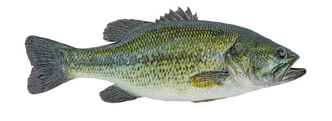 |  |  | 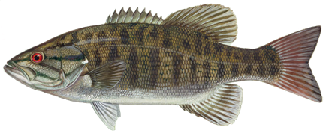
Largemouth Bass |  |  | Smallmouth Bass
Date Caught__________ | Location ___________________ |  | Date Caught____________ | Location _____________________
Length ______________ | Fly Used ___________________ |  | Length ______________ | Fly Used _____________________
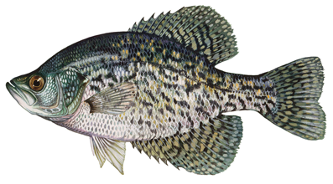 |  |  | 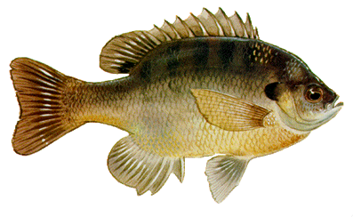
Crappie |  |  | Bluegill / Sunfish
Date Caught__________ | Location ___________________ |  | Date Caught____________ | Location _____________________
Length ______________ | Fly Used ___________________ |  | Length ________________ | Fly Used _____________________

Guidelines
Goal: Catch and release a Largemouth Bass, a Smallmouth Bass, a Bluegill, and a Crappie using a top water fly (examples include but not limited to popper, foam spider, foam frog, mouse patterns, stimulator, etc.) and fly tackle.
Rules:
- The fish must be photographed with minimal stress.
(We recommend using the Keep’em wet method, see www.KeepFishWet.org for principles and tips).
- The fish must be caught on a single barbless fly, using fly fishing tackle. A photo of the fly used for each fish must be submitted with the documentation.
- Application must include Popper Slam Log Sheet with pictures.
- Applicant must be a member in good standing to qualify for the award.
- All fish must be caught and posted after the challenge program start date of 5/9/2019.
How to Apply:
Send documentation and photographs to:
Boise Valley Fly Fishers
P.O. Box 311
Boise, ID 83701

Please share your progress with the club by posting updates to the BVFF Facebook Group Page.

